AI ASSISTANT
Lab 11.1
Task 1:
Prompt:
Generate a Python class named **Stack**.
The class should implement stack operations: **push, pop, peek, and is_empty**.
Requirements:
1. Use a Python list to store stack elements.
2. Implement the following methods:
* `push(item)` – add an element to the stack.
* `pop()` – remove and return the top element.
* `peek()` – return the top element without removing it.
* `is_empty()` – return True if the stack is empty, otherwise False.
3. Include **docstrings** explaining each method.
4. Handle edge cases such as popping or peeking from an empty stack.
5. Provide a simple example usage at the end.
Code:
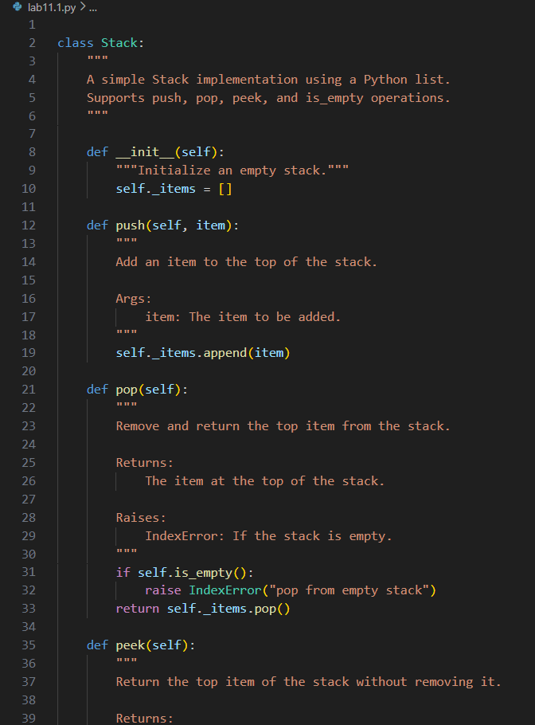
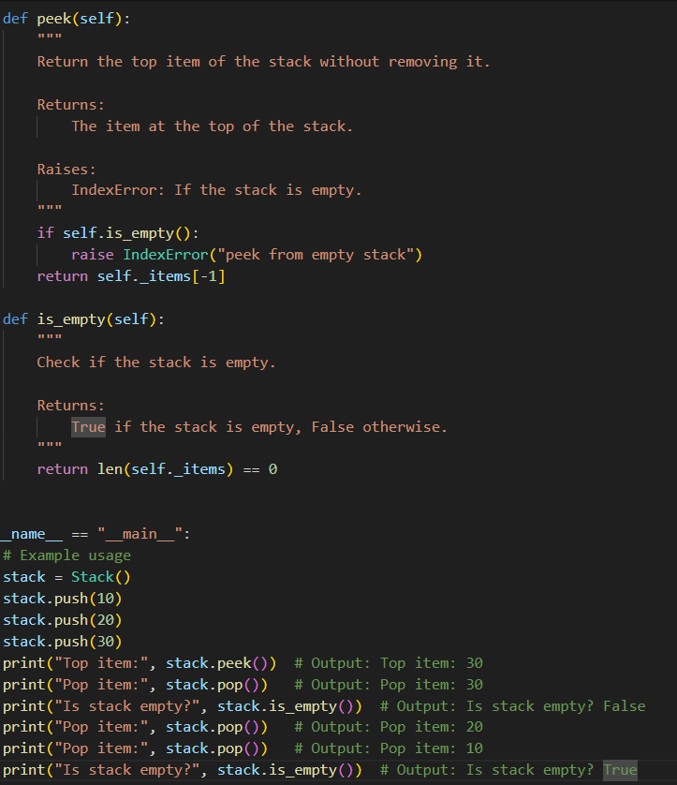

TASK2:
Prompt:
Generate a Python program that implements a Queue class using a list. The queue should follow the FIFO (First-In-First-Out) principle and include the methods enqueue(item), dequeue(), peek(), and size(). Add proper docstrings and provide a simple example demonstrating the queue operations.
Code:
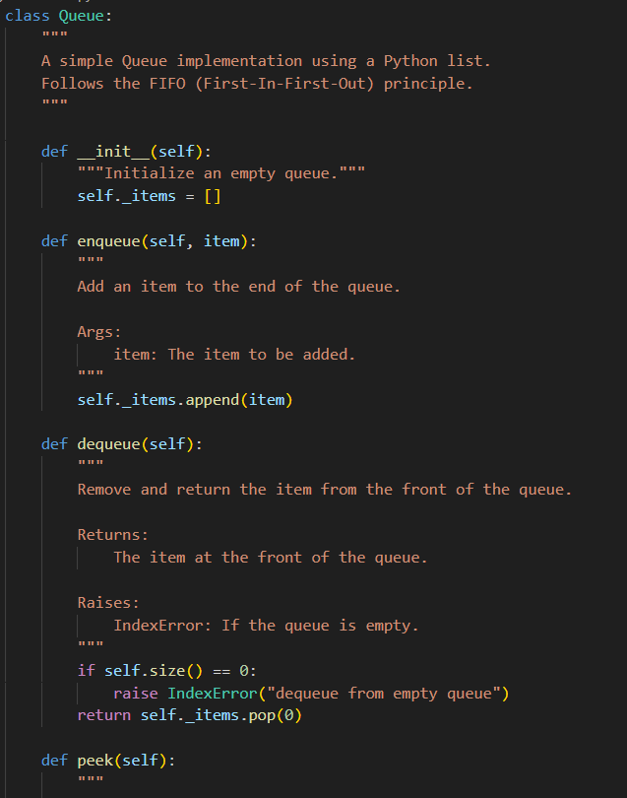
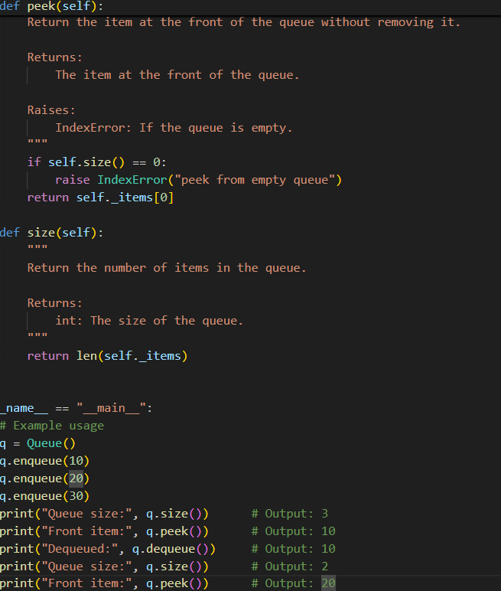

Task3:
Prompt:
Generate a Python program that implements a Singly Linked List. Create a Node class and a LinkedList class. The LinkedList should include methods insert(data) to add a new node and display() to print all elements in the list. Include proper docstrings for each class and method and provide a simple example demonstrating the linked list operations.
Code:
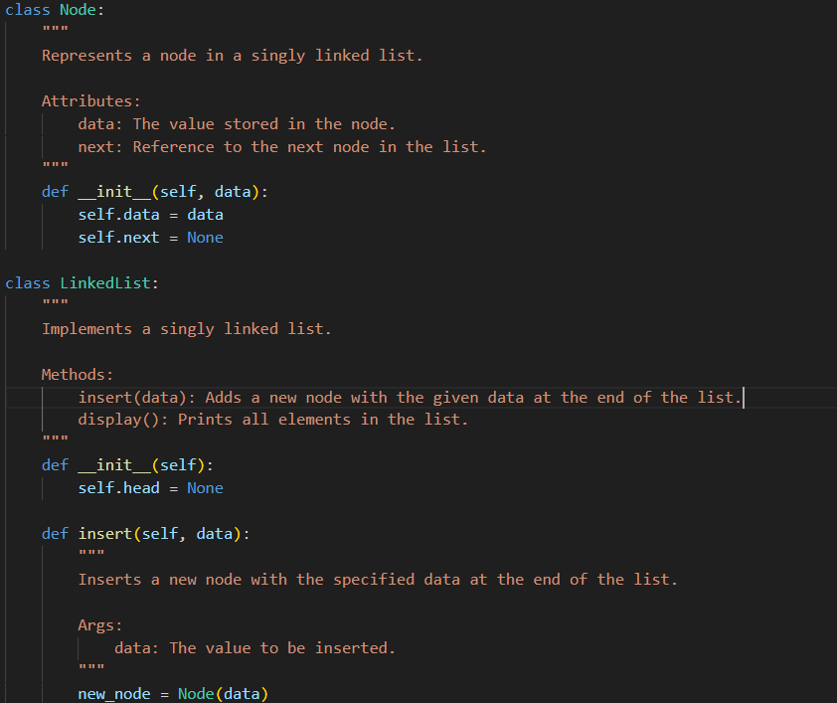
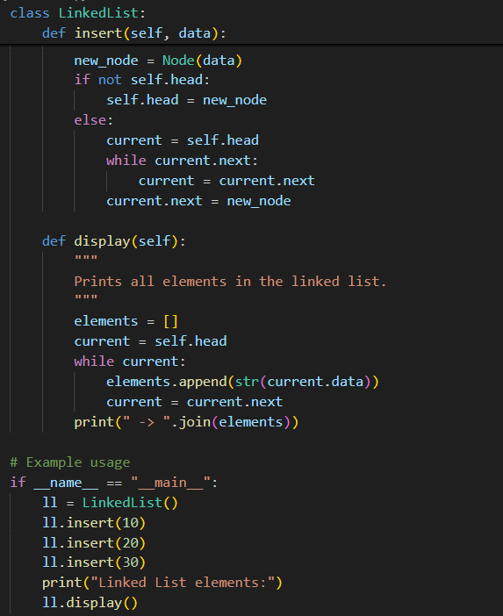
Task4:
Prompt:
Generate a Python program that implements a Binary Search Tree (BST). The class should include methods insert() to add elements and inorder_traversal() to display elements using in-order traversal. Use recursive methods, include proper docstrings, and provide a simple example demonstrating BST operations.
Code:
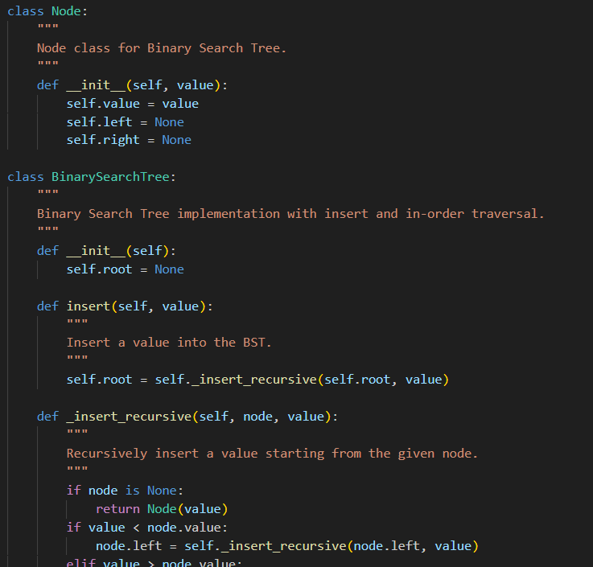
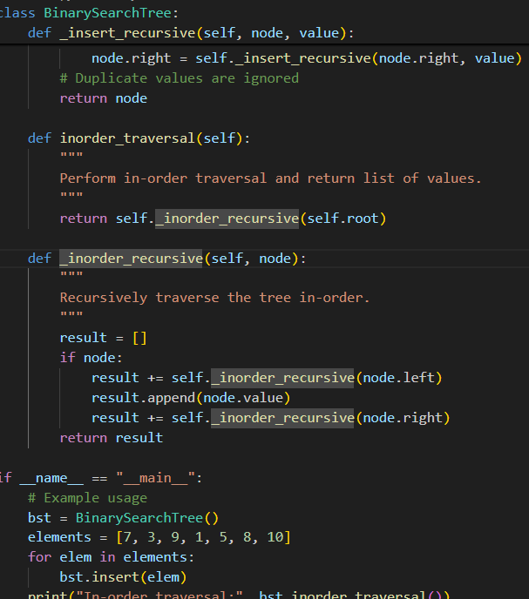
Task5:
Prompt:
Generate a Python program that implements a Hash Table using chaining for collision handling. The class should include methods insert(key, value), search(key), and delete(key). Add proper comments/docstrings and include a simple example demonstrating the hash table operations.
Code:
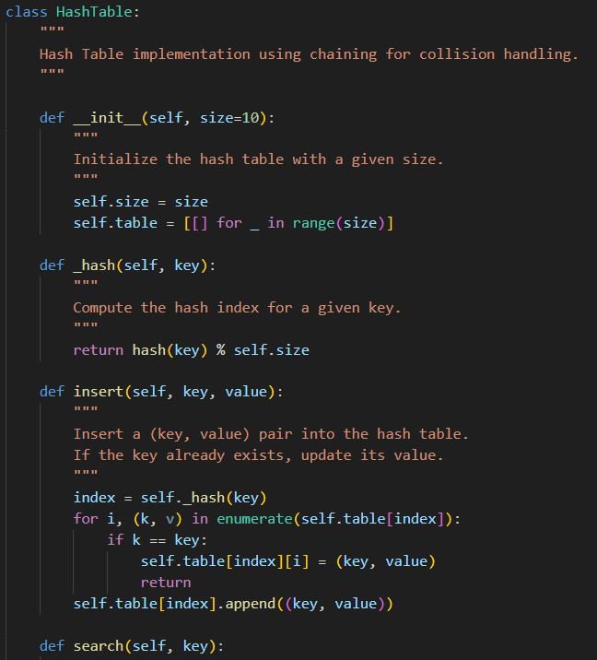
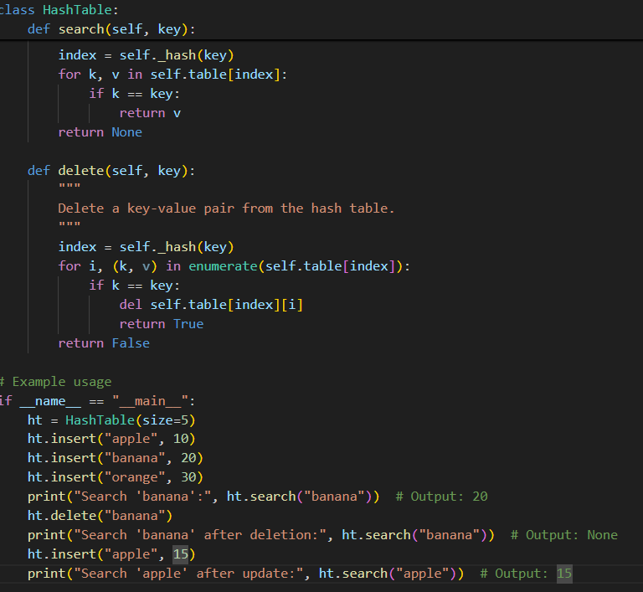
Task6:
Prompt:
Generate a Python program that implements a Graph using an adjacency list. The class should include methods add_vertex(), add_edge(), and display() to show the graph connections. Add proper comments/docstrings and include a simple example demonstrating graph operations.
Code:
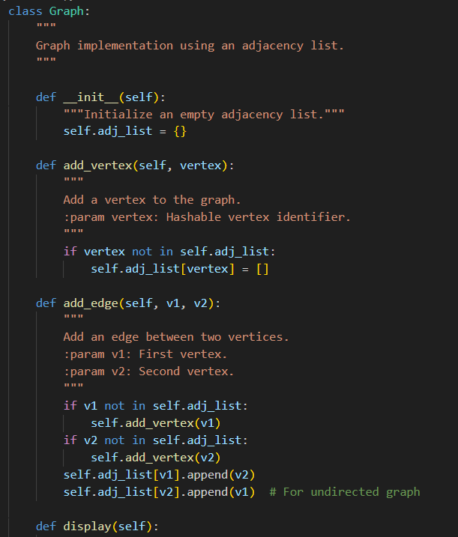
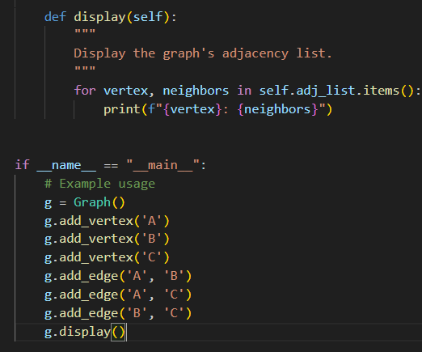
Task7:
Prompt:
Generate a Python program that implements a Priority Queue using Python’s heapq module. The class should include methods enqueue(item, priority), dequeue() to remove the highest priority element, and display() to show the queue elements. Add proper docstrings/comments and include a simple example demonstrating the priority queue operations.
Code:
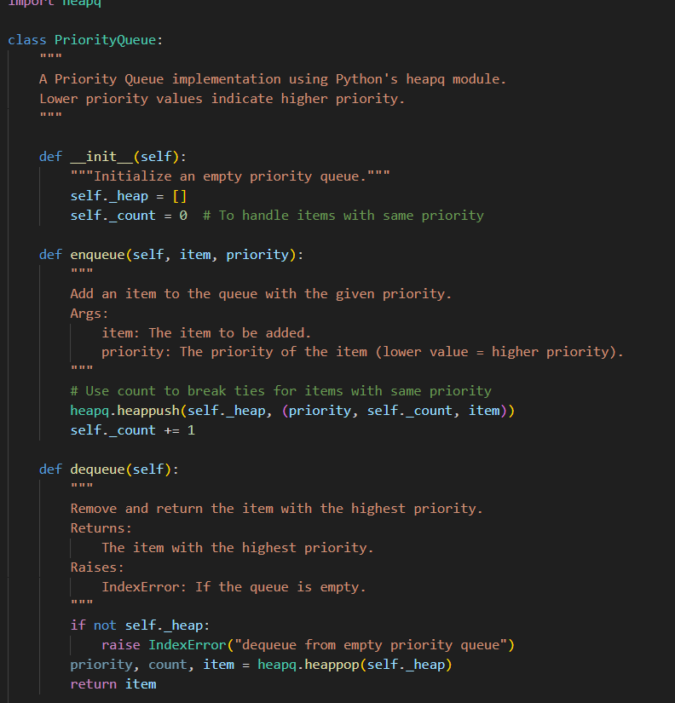
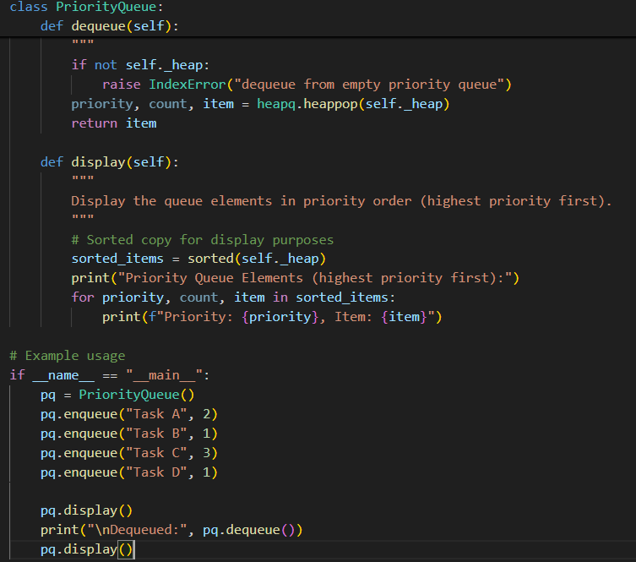
Task8:
Prompt:
Generate a Python program that implements a Deque (Double-Ended Queue) using collections.deque. The class should include methods to insert and remove elements from both the front and rear. Add proper docstrings/comments and include a simple example demonstrating deque operations
Code:
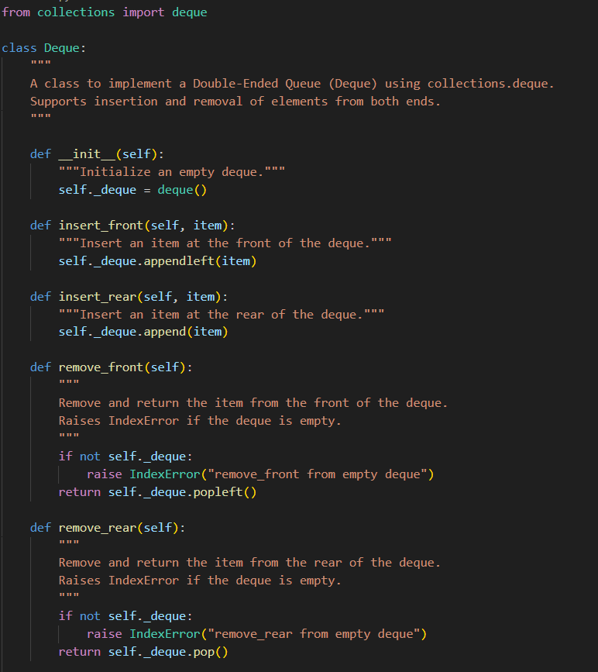

Task9:
Prompt:
Analyze the Campus Resource Management System features and select the most suitable data structure from the following list: Stack, Queue, Priority Queue, Linked List, Binary Search Tree (BST), Graph, Hash Table, and Deque.
For each feature (Attendance Tracking, Event Registration, Library Borrowing, Bus Scheduling, Cafeteria Order Queue), create a table mapping Feature → Chosen Data Structure → 2–3 sentence justification.
Then implement one selected feature as a Python program with proper comments and docstrings.
Code:
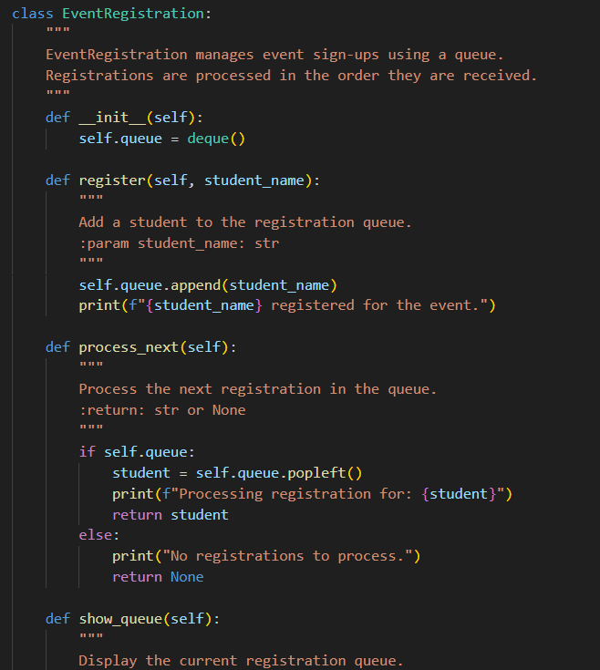
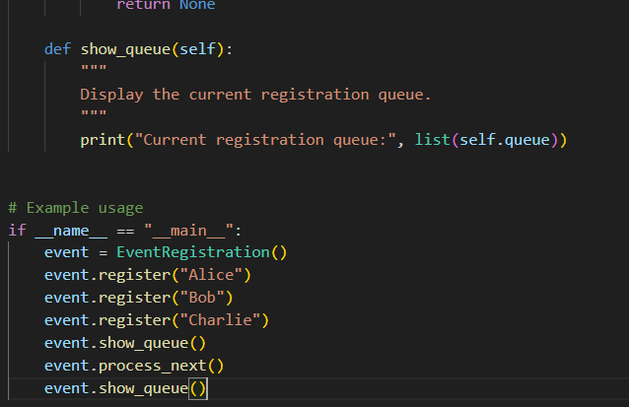
Task10:
Prompt:
Analyze the Smart E-Commerce Platform features and choose the most appropriate data structure from: Stack, Queue, Priority Queue, Linked List, Binary Search Tree (BST), Graph, Hash Table, and Deque.
For each feature (Shopping Cart Management, Order Processing, Top-Selling Products Tracker, Product Search Engine, Delivery Route Planning), create a table mapping Feature → Chosen Data Structure → 2–3 sentence justification.
Finally, implement one selected feature as a Python program with comments and docstrings demonstrating its functionality.
Code:
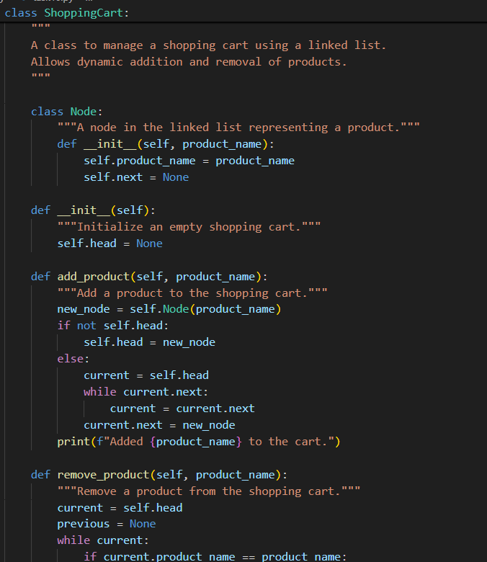
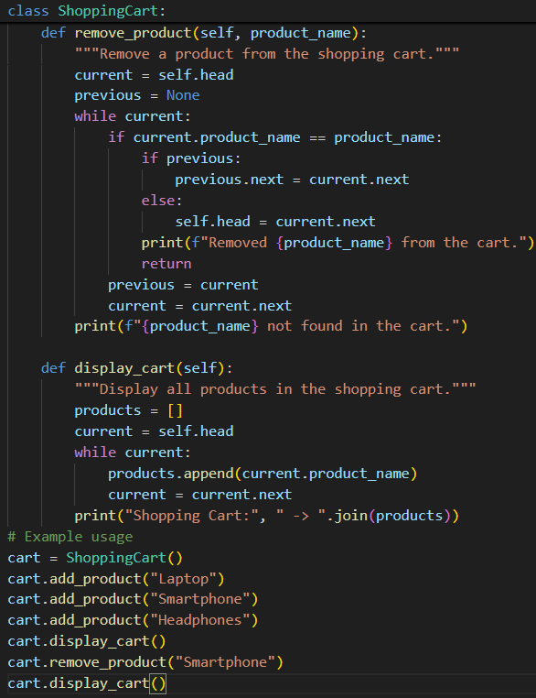
Outputs for above tasks:
